ZooKeeper的API学习

# ZooKeeper的API

<http://zookeeper.apache.org/doc/current/api/index.html>

在下载的ZooKeeper的tar.gz压缩包中，docs文件夹里面存放的也是html版的API。

# ZooKeeper类介绍

## 包：org.apache.zookeeper

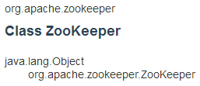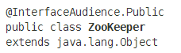

This is the main class of ZooKeeper client library. To use a ZooKeeper service, an application must first instantiate an object of ZooKeeper class. All the iterations will be done by calling the methods of ZooKeeper class. The methods of this class are thread-safe unless otherwise noted.

Once a connection to a server is established, a session ID is assigned to the client. The client will send heart beats to the server periodically to keep the session valid.

The application can call ZooKeeper APIs through a client as long as the session ID of the client remains valid.

## Constructor构造方法

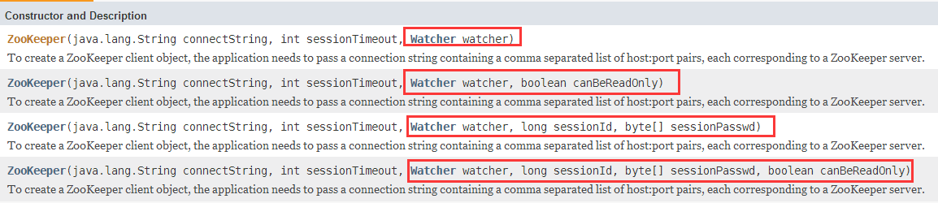

第一个参数：集群之间利用逗号隔开。comma(逗号)

格式：**host1:port1, host2:port2, host3:port3**

39.106.30.172:2181, 39.106.30.173:2181

第二个参数：有效时间，单位为毫秒。

## 操作方法分类

### create方法

java.lang.String **create(java.lang.String path, byte[] data, java.util.List<ACL> acl, CreateMode createMode)**

Create a node with the given path.

void **create(java.lang.String path, byte[] data, java.util.List<ACL> acl, CreateMode createMode, AsyncCallback.StringCallback cb, java.lang.Object ctx)**

The asynchronous version of create.

### delete方法

void **delete(java.lang.String path, int version)**

Delete the node with the given path.

void **delete(java.lang.String path, int version, AsyncCallback.VoidCallback cb, java.lang.Object ctx)**

The asynchronous version of delete.

### setData方法

Stat **setData(java.lang.String path, byte[] data, int version)**

Set the data for the node of the given path if such a node exists and the given version matches the version of the node (if the given version is -1, it matches any node's versions).

void **setData(java.lang.String path, byte[] data, int version, AsyncCallback.StatCallback cb, java.lang.Object ctx)**

The asynchronous version of setData.

### getData方法

void **getData(java.lang.String path, boolean watch, AsyncCallback.DataCallback cb, java.lang.Object ctx)**

The asynchronous version of getData.

byte[] **getData(java.lang.String path, boolean watch, Stat stat)**

Return the data and the stat of the node of the given path.

void **getData(java.lang.String path, Watcher watcher, AsyncCallback.DataCallback cb, java.lang.Object ctx)**

The asynchronous version of getData.

byte[] **getData(java.lang.String path, Watcher watcher, Stat stat)**

Return the data and the stat of the node of the given path.

### exists方法

Stat **exists(java.lang.String path, boolean watch)**

Return the stat of the node of the given path.

void **exists(java.lang.String path, boolean watch, AsyncCallback.StatCallback cb, java.lang.Object ctx)**

The asynchronous version of exists.

Stat **exists(java.lang.String path, Watcher watcher)**

Return the stat of the node of the given path.

void **exists(java.lang.String path, Watcher watcher, AsyncCallback.StatCallback cb, java.lang.Object ctx)**

The asynchronous version of exists.

### sync方法

void sync(java.lang.String path, AsyncCallback.VoidCallback cb, java.lang.Object ctx)

Asynchronous sync.

### getChildren方法等

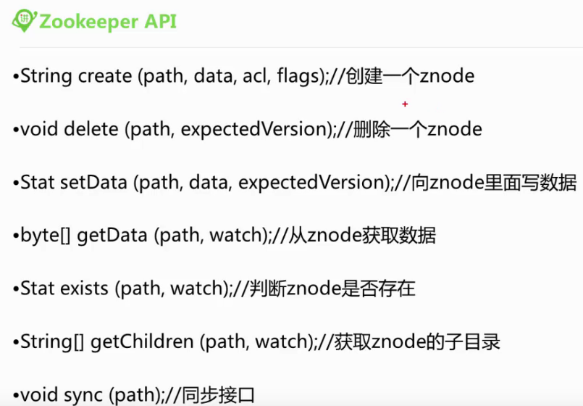

# ZooKeeper.States

## ZooKeeper的状态

ZooKeeper.States是一个枚举类，定义了ZooKeeper的所有状态。

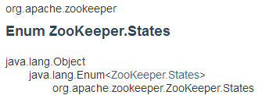

## ZooKeeper的状态

**ASSOCIATING**

**AUTH_FAILED**

**CLOSED**

**CONNECTED**

**CONNECTEDREADONLY**

**CONNECTING**

**NOT_CONNECTED**

## 方法

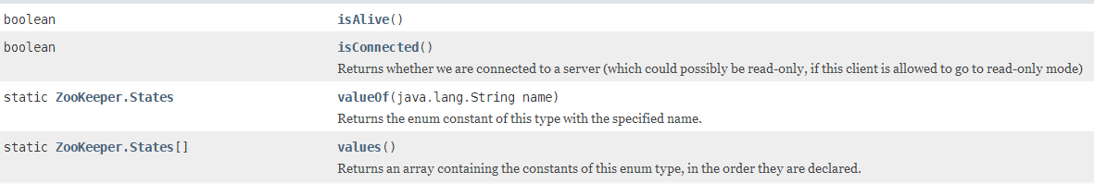

# Stat类

## Stat

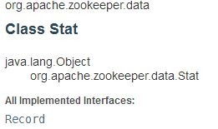 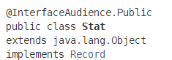

## 构造方法2个：

一个空参，一个是11个参数。



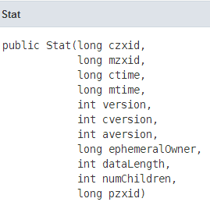

# Watcher接口

## Watcher接口介绍

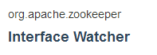 

This interface specifies the public interface an event handler class must implement. A ZooKeeper client will get various events from the ZooKeeper server it connects to. An application using such a client handles these events by registering a callback object with the client. The callback object is expected to be an instance of a class that implements Watcher interface.

创建一个ZooKeeper连接，必须实现Watcher方法。

## 接口方法process

实现该接口，必须实现process方法：

